**Object Pool Design Pattern**

The Object Pool design pattern is a creational pattern that aims to reduce the cost of creating and disposing of objects by reusing a fixed set of objects instead of creating and destroying them on demand. This pattern is particularly useful for managing resources that are expensive to create or maintain, such as database connections, thread pools, or large objects.

**Definition**

The Object Pool pattern manages a pool of reusable objects. When an object is needed, a client borrows it from the pool, uses it, and returns it to the pool. This approach helps to optimize performance and resource usage by reusing existing objects instead of constantly creating new ones.

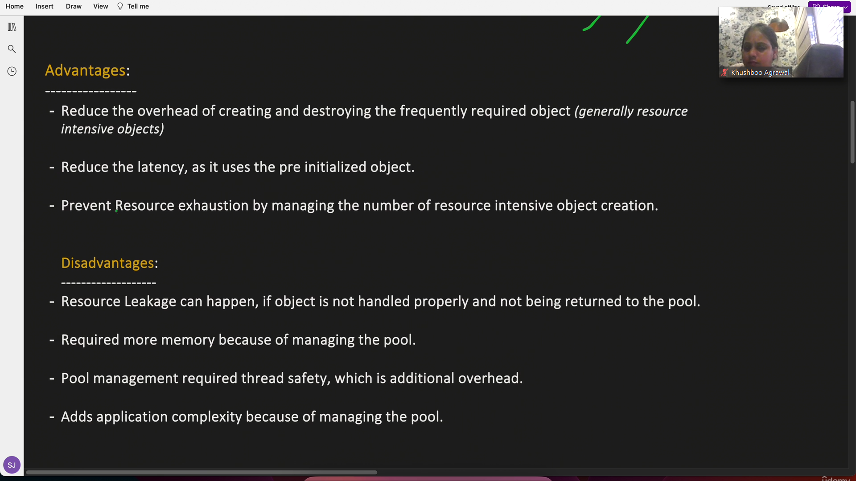

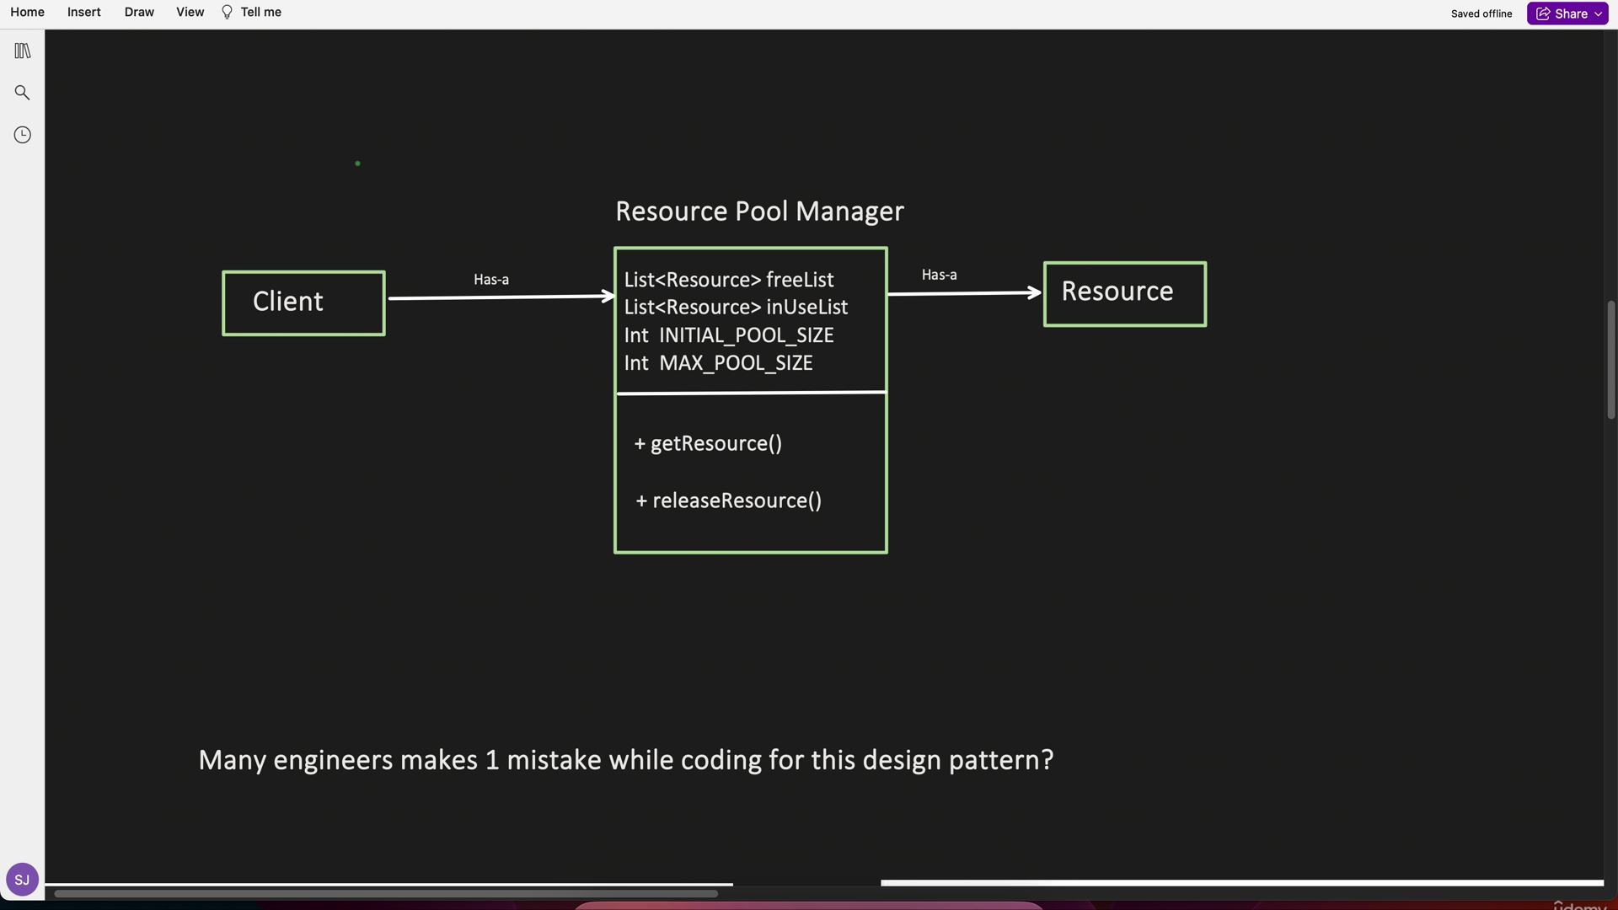

**Example**

Consider a scenario where we need to manage a pool of database connections.



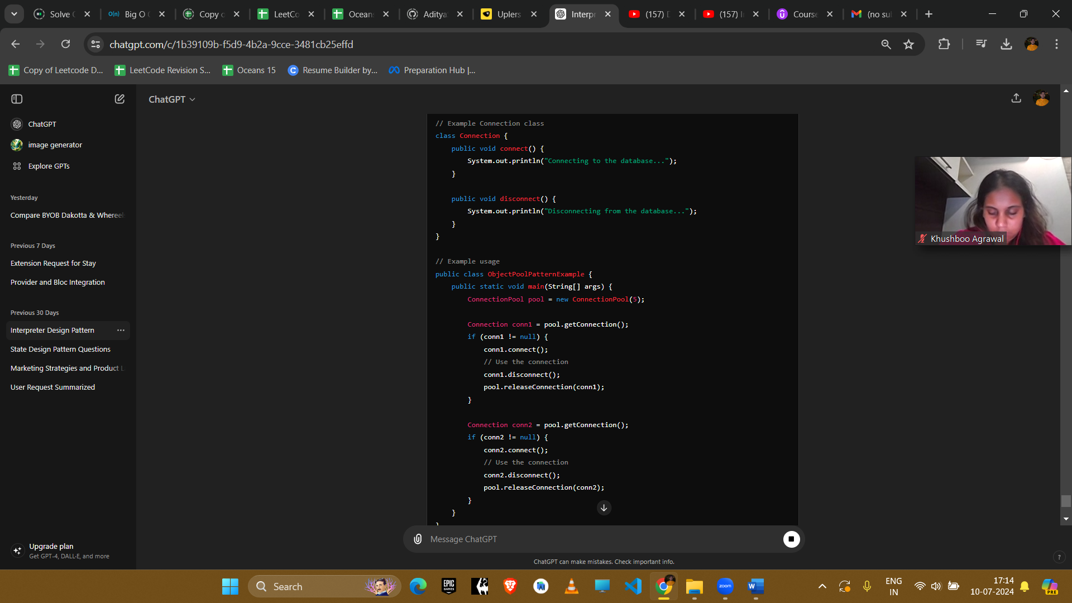

**Explanation**

1. **Object Pool Class**: ConnectionPool manages a pool of Connection objects. It keeps track of which connections are available and which are in use.
2. **Client Code**: The client borrows a Connection object from the pool, uses it, and then returns it to the pool.

**Example Uses in Amazon Interviews**

1. **Database Connections**
   * **Scenario**: Managing a pool of database connections to optimize resource usage and improve performance.
   * **Implementation**: Use the Object Pool pattern to reuse database connections, reducing the overhead of creating and closing connections frequently.
2. **Thread Pools**
   * **Scenario**: Managing a pool of threads for executing tasks in a multithreaded application.
   * **Implementation**: Use the Object Pool pattern to reuse threads, improving performance and resource management.
3. **Reusable Objects**
   * **Scenario**: Managing reusable objects such as memory buffers, large data structures, or network connections.
   * **Implementation**: Use the Object Pool pattern to manage these objects efficiently, reducing the cost of frequent object creation and disposal.
4. **Caching**
   * **Scenario**: Implementing a cache for frequently accessed data or objects.
   * **Implementation**: Use the Object Pool pattern to store and reuse cached objects, improving performance and reducing latency.

**Conclusion**

The Object Pool pattern is effective for optimizing resource management and performance in scenarios where the cost of creating and destroying objects is high. By reusing objects from a pool, this pattern helps to reduce resource consumption and improve the efficiency of applications. It is particularly useful for managing expensive-to-create resources like database connections, threads, and large objects.